MATH 1530 CAPSTONE TECHNOLOGY PROJECT FALL 2017

Problem 1: Identify Variable Type. Which of these questions from the class survey produced variables that are categorical and which are quantitative? Use your word processor to underline/highlight the best option.

a. AGE Categorical Quantitative Neither

Produce an appropriate plot for this variable.
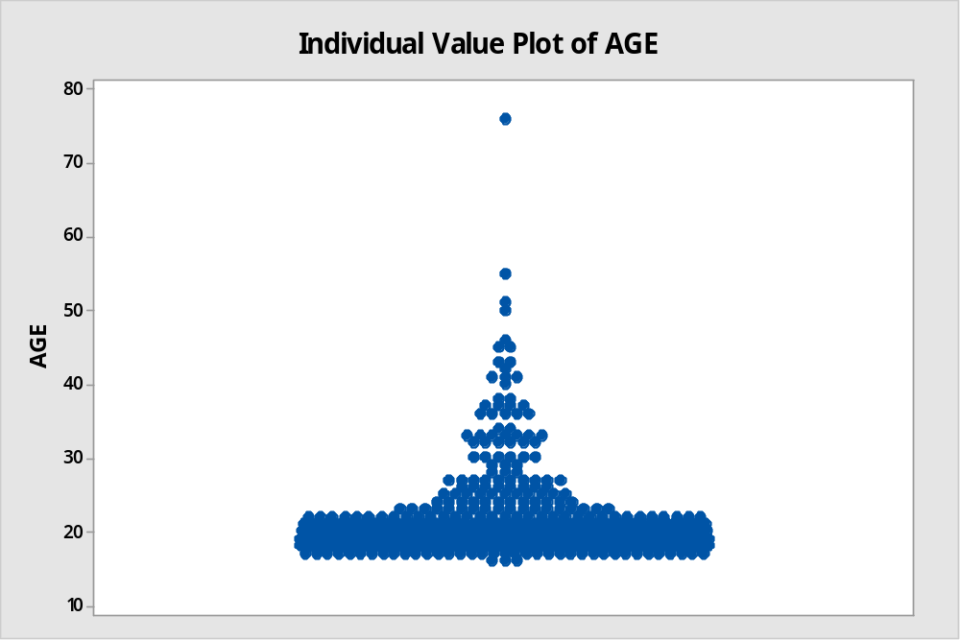

b. SHOPS Categorical Quantitative Neither

Produce an appropriate plot for this variable.
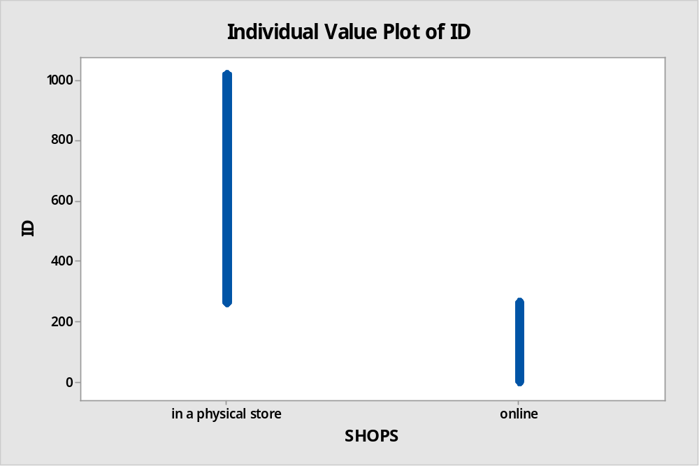

c. OFFERED Categorical Quantitative Neither

Produce an appropriate plot for this variable.
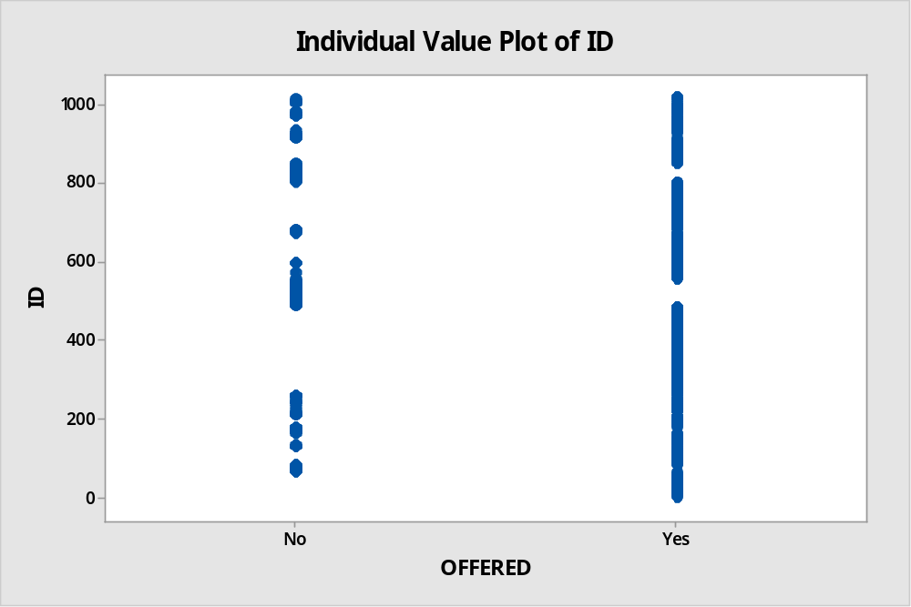

Problem 2: Sampling. In the survey data, the variable “AGE” is the age in years for each student.

a. Type the first 10 observations from the column representing the variable AGE into the table below, and use this as your sample data for part (b). Then calculate the mean age of these first 10 observations and report the value below.

N | 1 | 2 | 3 | 4 | 5 | 6 | 7 | 8 | 9 | 10
AGE | 43 | 18 | 18 | 18 | 18 | 25 | 18 | 20 | 25 | 21

b. The mean age of the first 10 students is _22.4__. (Type the value into the space provided.)
c. Next, select a random sample of size n = 10 (Go to Calc > Random Data > Sample from Columns). Type the number 10 in the “Number of rows to Sample” slot. Enter the variable “ID” and “AGE” into the “From columns” slot. Enter C17-C18 into the “Store samples in” slot. Record the data for your sample in the table below.

N | 1 | 2 | 3 | 4 | 5 | 6 | 7 | 8 | 9 | 10
ID | 645 | 477 | 878 | 506 | 142 | 341 | 370 | 610 | 995 | 543
AGE | 18 | 19 | 18 | 18 | 18 | 19 | 18 | 36 | 18 | 19

d. Calculate and report the mean age for your random sample of 10 students. The sample mean age is __20.10__.

e. Suppose we think of all the students who responded to the survey as a population for the purposes of this problem. In that case, the population mean age is 20.001. Discuss (two or more complete sentences) the differences and similarities between 20.001 and the answers you got in (b) and (d).
The sample mean (in part d.) is less accurate but it is manageable than the population mean (in part b.)

Problem 3(e): If your E number ends in an even number (0, 2, 4, 6, or 8) then do this question. (Omit this page/problem if your E# ends with an odd number.)

- Question 3 of the FALL 2017 survey asked students, “Approximately how much did you spend on textbooks this semester (Round to the nearest whole dollar)?”

a. Create an appropriate graph to display the distribution of the variable called TEXTBOOKS and insert it here.

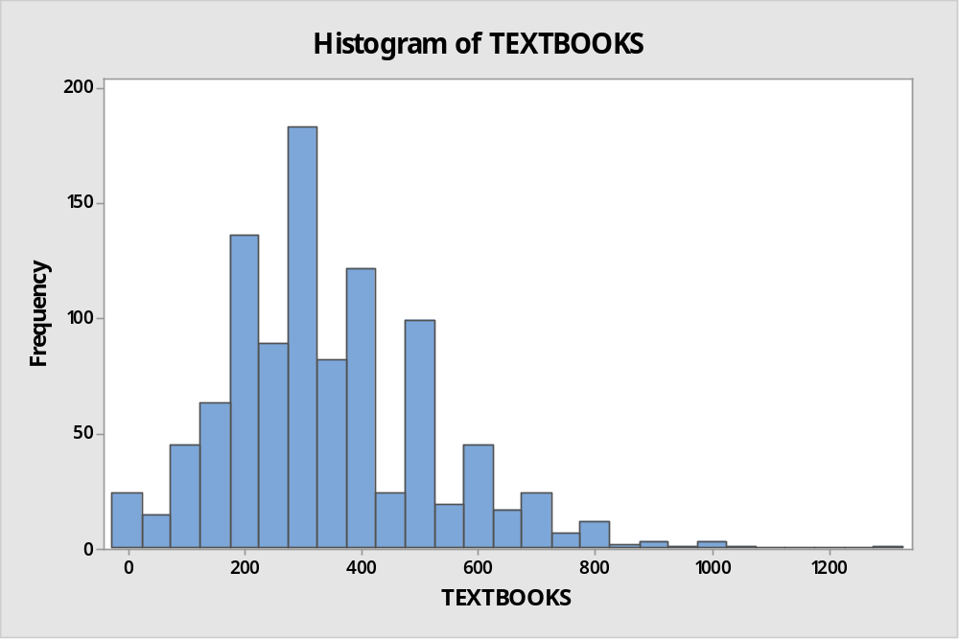

b. Which of the following best describes the shape of the distribution? Underline (or highlight) your answer.
Skewed left Uniform Skewed right Bimodal Symmetric

c. Using Minitab, calculate the basic statistics for the data collected on TEXTBOOKS. Copy and paste all of the Minitab output here.
Descriptive Statistics: TEXTBOOKS
Statistics
Variable | N | N* | Mean | SE Mean | Standard Dev | Minimum | Q1 | Median | Q3 | Maximum
TEXTBOOKS | 1017 | 0 | 341.13 | 5.64 | 179.86 | 0.00 | 200.00 | 300.00 | 433.00 | 1300.00

Choose statistics that are appropriate for the shape of the distribution to describe the center and spread of TEXTBOOKS.

d. Which statistic will you use to describe the center of the distribution? ____median_____

e. In one or two sentences, describe why this statistic was chosen.
The median is the middle of the statistical data and gives the centre of the data.

f. What is the value of that statistic? _______300.00_______

g. Which statistic(s) will you use to describe the spread of the distribution? ____minimum and maximum____

h. What is (are) the value(s) of that (those) statistic(s)? _____0.00 and 1300.00______

i. Are there any outliers in this distribution? Justify your answer using the IQR rule or an appropriate plot.
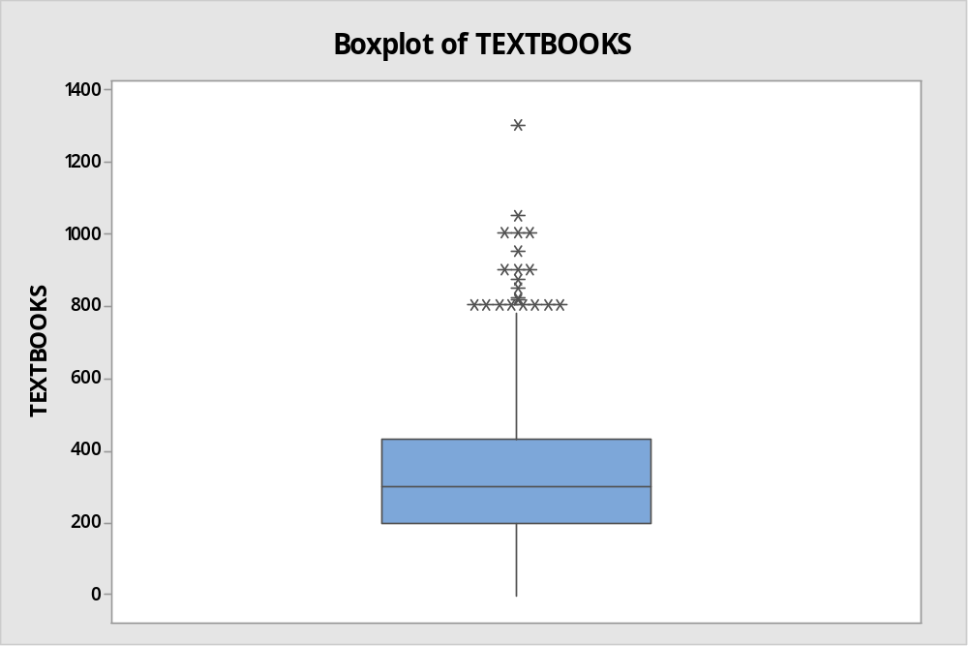

Problem 4: SMOKE versus AGE. Question 1 of the survey asked students, “What is your age (in years)?” Question 12 of the survey asked students, “What is your current smoking status? (Current smoker, Former smoker, Non-smoker)”
a. Create a suitable graph to display the distribution of SMOKE and insert it here.
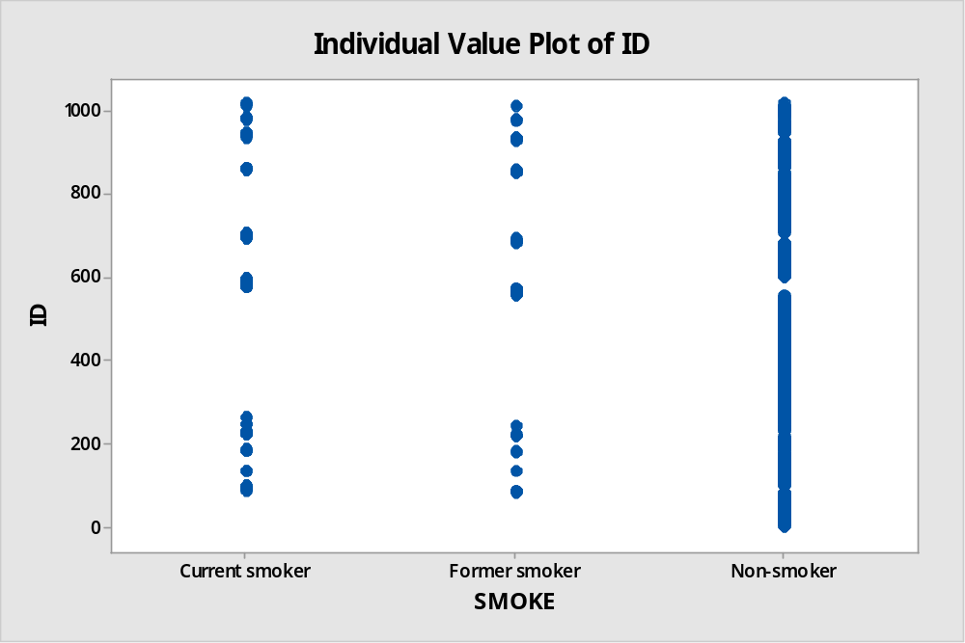

b. What is the mode of this distribution? Underline (or highlight) one option.

Current Smoker Former Smoker Non-smoker

c. Create a side-by-side boxplot to display the age of students for the different levels of SMOKE. (Go to Graph > Boxplot > One Y with Groups > OK. Select AGE for the “Graph variables” slot and SMOKE for the “Categorical variables for grouping” slot.)
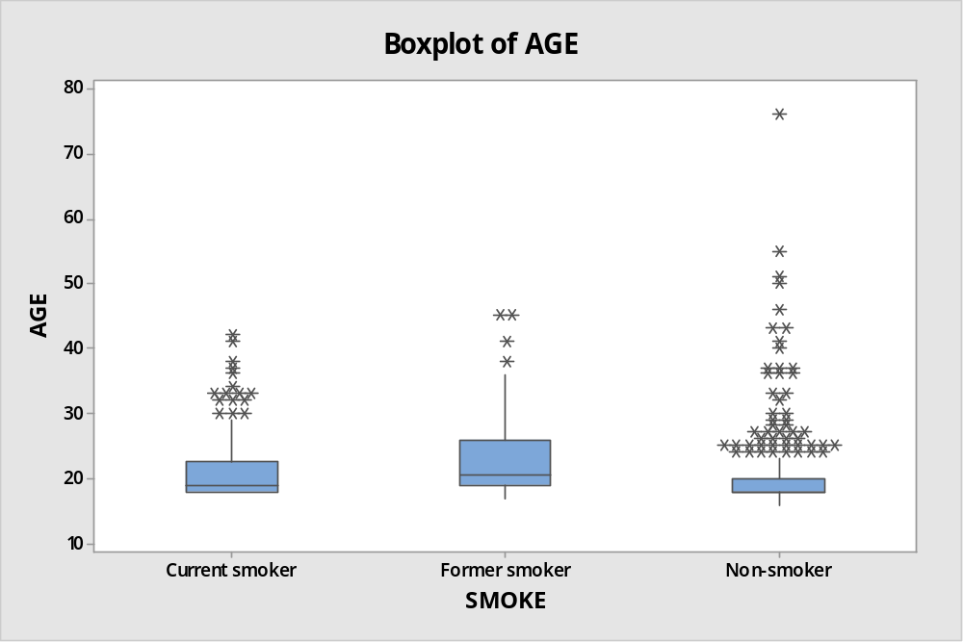

Use the side-by-side boxplot found in part (c) to answer the following questions.

d. Which smoking status has the oldest student? ____Former smoker____

e. Which smoking status has the highest median age? _____current smoker_____

f. Which smoking status has the smallest IQR? ______Non-smoker______

Problem 5: STATES vs. COUNTRIES. On the FALL 2017 Math 1530 survey, question 8 asked students, “How many U.S. states have you visited, not including the state you were born? (Enter zero if you have never traveled outside the state you were born.)” and question 9 asked students, “How many countries have you visited, not including the country you were born? (Enter zero if you have never traveled outside the country you were born.)” We are interested in seeing whether we can use the number of states visited to predict the number of countries visited.
- Create an appropriate graph to display the relationship between STATES and COUNTRIES.

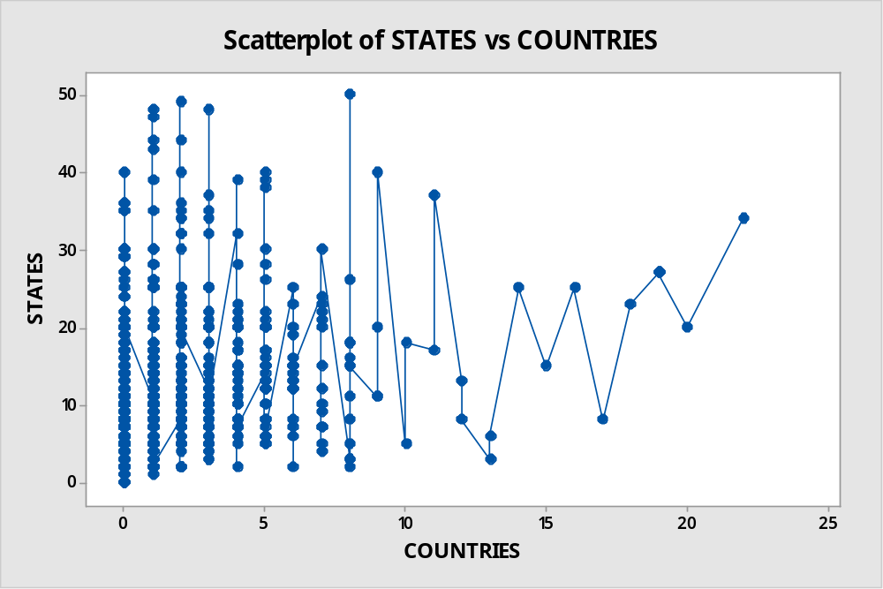

- Does the plot show a positive association, a negative association, or no association between these two variables? EXPLAIN what this means with respect to the variables being studied.

Correlations
Pearson correlation | 0.282
P-value | 0.000

The plot shows a positive association. The Pearson’s correlation is positive.

c. Describe the form of the relationship between STATES and COUNTRIES.
Positive relationship because the Pearson’s correlation is positive as shown below.
Pearson correlation | 0.282
P-value | 0.000

d. Report the value of the correlation between this pair of variables? r = __0.282___

e. Based on the information displayed in the graph and the correlation you just reported, how would you describe the strength of the association?
The strength of the assocuiation is significant between the two variables

f. Using Minitab, obtain the equation for the least squares regression of STATES on COUNTRIES. Copy & paste the output here.

Polynomial Regression Analysis: STATES versus COUNTRIES
The regression equation is
STATES = 9.830 + 1.263 COUNTRIES - 0.03586 COUNTRIES^2
Model Summary
S | R-sq | R-sq(adj)
7.49993 | 8.66% | 8.48%
Analysis of Variance
Source | DF | SS | MS | F | P
Regression | 2 | 5404.6 | 2702.28 | 48.04 | 0.000
Error | 1014 | 57036.4 | 56.25
Total | 1016 | 62441.0
Sequential Analysis of Variance
Source | DF | SS | F | P
Linear | 1 | 4979.48 | 87.96 | 0.000
Quadratic | 1 | 425.08 | 7.56 | 0.006
Fitted Line: STATES versus COUNTRIES

g. Interpret the value of the slope in the least squares regression equation you found in part (f).
The slope is 7.49993. This shows the average of nations per country one has visited

h. Use the regression equation in part (f) to predict the number of countries visited for a student that has visited 8 U.S. states. (Show your math.)
From the regression equation:
STATES = 9.830 + 1.263 COUNTRIES
8=9.830 +1.263 COUNTRIES

Predicted number of countries visited = -1.44893

- How well does the regression equation fit the data? Explain. Justify your answer with appropriate plot(s) and summary statistics.

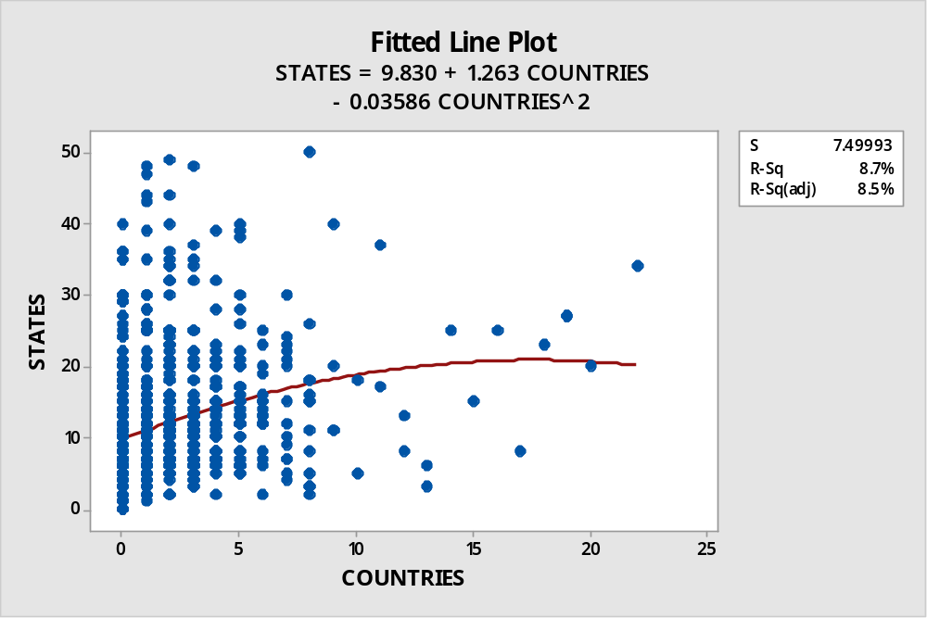

Descriptive Statistics: STATES, COUNTRIES
Statistics
Variable | N | N* | Mean | SE Mean | StDev | Minimum | Q1 | Median | Q3 | Maximum
STATES | 1017 | 0 | 11.465 | 0.246 | 7.839 | 0.000 | 6.000 | 10.000 | 15.000 | 50.000
COUNTRIES | 1017 | 0 | 1.5644 | 0.0833 | 2.6569 | 0.0000 | 0.0000 | 1.0000 | 2.0000 | 22.0000

Problem 6 (T): Flip a fair coin. If it lands on tails do this problem (Omit this page/problem AND DO PROBLEM 6(H) if it lands on heads.)

OFFERED AND SMOKE_MARIJUANA: Question 13 from the FALL 2017 Math 1530 survey asked students “Have you ever been offered to smoke marijuana? (Yes, No)” and Question 14 of the survey asked students, “Have you ever smoked marijuana? (Yes, No).” We want to check if there is a relationship between OFFERED AND SMOKE_MARIJUANA among ETSU students. Assume the students who took the (FALL 2017 Math 1530) class survey are from an SRS of ETSU students.

- Create an appropriate graph to display the relationship between OFFERED and SMOKE_MARIJUANA. Insert your graph here.

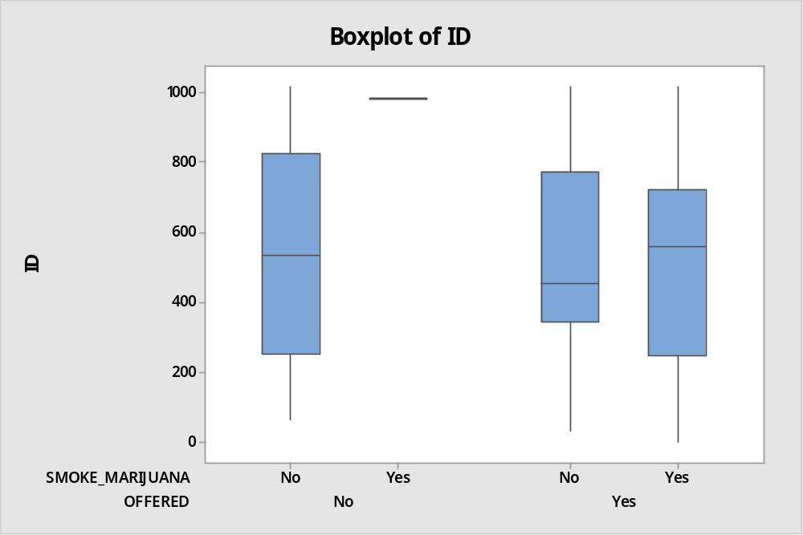

- Create an appropriate two-way table to summarize the data. Insert your table here. (IN MINITAB: STAT TABLES CROSS TABULATION AND CHI-SQUARE. Make sure to select “Options” and click “No variables” under the “Display missing values for”).
Tabulated Statistics: OFFERED, SMOKE_MARIJUANA
Rows: OFFERED Columns: SMOKE_MARIJUANA
 | No | Yes | All
No | 220 | 2 | 222
Yes | 314 | 481 | 795
All | 534 | 483 | 1017
- Cell Contents
Count

SUPPOSE WE SELECT ONE STUDENT AT RANDOM: (Calculate the following probabilities and show your work.)

- What is the probability that this student has been offered marijuana and has smoked marijuana?

P = 481/795 *481/483 = 0.60252614034

d. What is the probability that this student identifies has been offered marijuana or has smoked marijuana?

P = 481/795

e. What is the probability that this student has not smoked marijuana given that the student has been offered marijuana?

P = _____314/795______
f. What is the probability that this student has been offered marijuana given that the student has not smoked marijuana?

P = _____314/534_______
Problem 7: In 2017, Business Insider did a story on using a mathematical theory to determine the best age to get married. This story reported the best age to get married was 26. (http://www.businessinsider.com/best-age-to-get-married-is-26-2017-2). Question 10 of the survey asked students, “At what age do you think is the best to get married in order to have a successful marriage?” On average, is the age that ETSU students believe is ideal to get married in order to have a successful marriage the same as reported in the story, 26?

- Create a suitable graph to display the distribution of MARRIAGE reported by our sample of college students and insert it here.
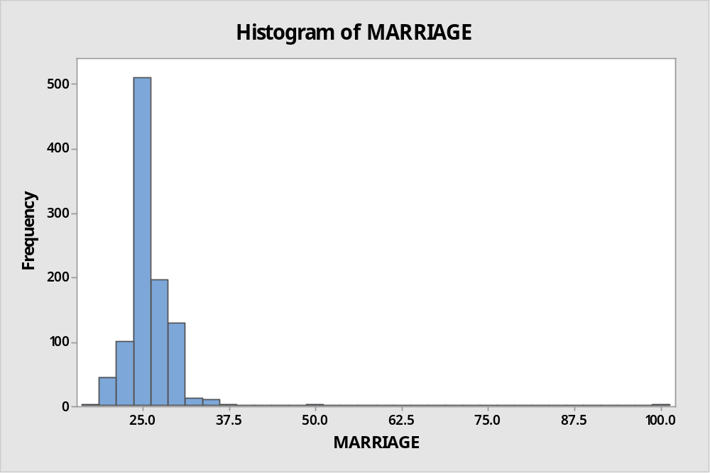

Perform a test of significance to see if, on average, the age that ETSU students believe is ideal to get married in order to have a successful marriage the same as reported in the story, 26, using α = 0.05.
One-Sample Z: MARRIAGE
Descriptive Statistics
N | Mean | StDev | SE Mean | 95% CI for μ
1017 | 26.224 | 5.193 | 0.163 | (25.905, 26.543)
μ: mean of MARRIAGE
Known standard deviation = 5.1932
Test
Null hypothesis | H₀: μ = 26.2242
Alternative hypothesis | H₁: μ ≠ 26.2242

Z-Value | P-Value
-0.00 | 1.000
From the hypothesis test done, we are 95% that the mean of the population is between (25.905, 26.543). Therefore it is true that most students in ETSU get married at the age of 26

- Write the correct null and alternative hypothesis for the test: _______
Null hypothesis | H₀: μ = 26.2242
Alternative hypothesis | H₁: μ ≠ 26.2242

- Use Minitab to perform the appropriate test. Copy and paste the output for the test here.

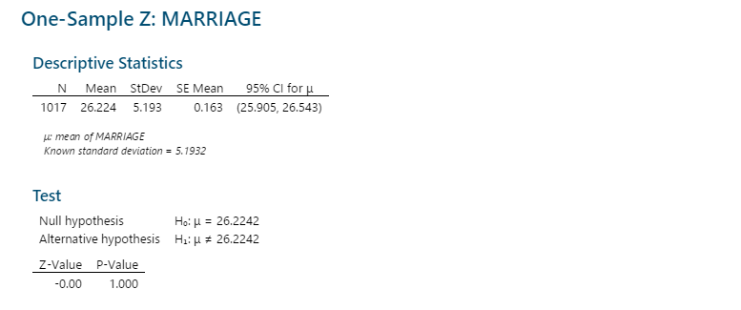

d. What is the name of your test statistic and what is its value? __z-test _____

e. What is the P-value for the test? P = ___1.000__

f. State your decision regarding the hypotheses being tested.
The p value is 1.000 more than the significant value (0.05) therefore fail to reject the null hypothesis

g. State your conclusion. USE COMPLETE SENTENCES.
The analysis shows that we fail to reject the null hypothesis

h. Is the P-value valid in this case? _______
The p-value is more than 0.05 indicates weak evidence against the null hypothesis
i. What assumptions are you making in order to carry out this test?
There is assumption that both sample and population data are independent sampling from a normal distribution.
Bonus Problem: Question 11 on the FALL 2017 Math 1530 asked, “Which comes closest to your opinion about Confederate monuments in public spaces: “They should be removed.”, “They should remain.”, or “I do not know.”? (They should be removed, They should remain, I do not know)” An online survey conducted by the software company icitizen reported that 43% of adults said the monuments should be remain (https://hyperallergic.com/397792/polls-americans-confederate-statues-removal/ ). Is the same true for the population of all U.S. college/university students?

a. Create an appropriate graph to display the distribution of MONUMENTS and insert it here.

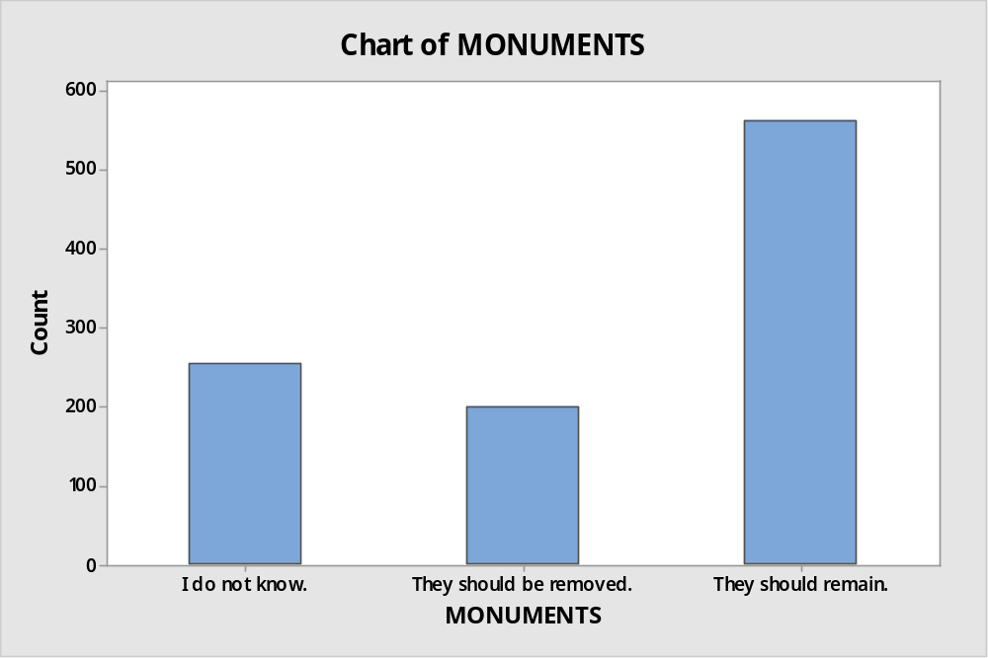

b. How many of the students surveyed said “They should remain?”
563 students

c. What proportion of our sample said “They should remain?”
563:1017

d. Assume (for the purpose of this problem) that we may treat the FALL 2017 sample of Math-1530 students as a simple random sample drawn from the population of all U.S. college/university students. Use Minitab to calculate a 95% confidence interval for the proportion of students in the population who chose “They should remain” to the survey question (based on our sample data). Copy and paste the Minitab output here.

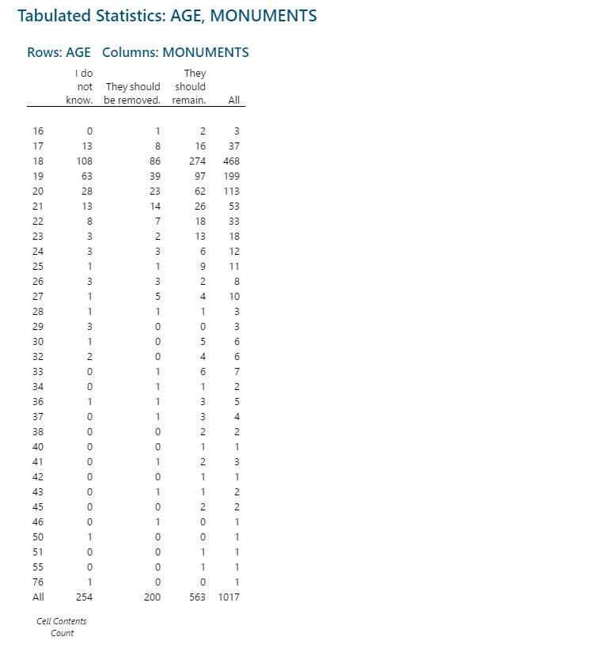

e. Interpret the confidence interval you reported in part (d).

P-value =Should remain/Total sample
=563/1017 = 0.55358898721
Confidence interval= p-value ±critical value * standard deviation
= 0.55359 ± 0.05 * 0.02107
= 0.55359 ± 0.00105
=55. 36% ± 0.00105

- What do you think? Do our results contradict the results obtained from survey by icitizen or do they appear to agree with it? EXPLAIN.

Yes. The difference is due to the error in calculation and during the sampling method.

